

  PJT03025.R4B.SAP.FS.BI.Rate.Analysis.Reports | 

REVIEWER(S)
Name | Title | Department | Reviewed (date/time)
Manoj Ajgaonkar | SAP QA Advisor | Smart Energy Program | <Date / Time>
Scott Tingle | AMI Program Lead | BTS | <Date / Time>
Chaitanya Kodela | Solution Architect | BTS SDM-Application Platform Svcs | <Date / Time>
Nitish Walia | Solution Architect, Capgemini | Smart Energy Program | <Date / Time>
Jack Hobbick | PROG TESTING SOLUTIONS MG | AMI Opers & Impl | <Date / Time>
Amit Jadli | Test Lead, Capgemini | Smart Energy Program | <Date / Time>
Jessica Scott | Audit Controls, Deloitte | Smart Energy Program | <Date / Time>
Clark Oeler | Audit Controls, Deloitte | Smart Energy Program | <Date / Time>

APPROVER(S)
Name | Title | Department | Approval (date/time)
Loknath Sri | SAP lead, CMS Energy | Smart Energy Program | <Date / Time>
Ramesh Swarna | SAP Lead, Capgemini | Smart Energy Program | <Date / Time>
Susana V Ward | BTS TECH TEAM LD/ PROJ MGR | BTS SDM | <Date / Time>
Chad Conrad | BTS PROJECT MGR II | BTS SDM | <Date / Time>
Zach Pakkala | Business Support Consultant | CE&O Customer Billing Services | <Date / Time>

CONTRIBUTORS
Name | Organization | Area of Contribution
Dominic Pappaly | Capgemini | Billing
Rajesh Pandey | Capgemini | Billing

VERSION HISTORY

Version | Date | Author(s) | Revision Notes
0.1 | 11/03/14 | Capgemini | Initial Version

Table of Contents

REVIEWER(S) 2
APPROVER(S) 2
1 OBJECT REQUIREMENT SUMMARY 5
1.1 Object Information and Attributes 5
1.2 Requirements Summary and Business Driver 6
1.3 Current Functionality 7
1.4 Required Functionality 7
1.5 Assumptions 7
1.6 Project / Development Constraints 8
1.7 Performance Criteria 8
2 DETAILED SPECIFICATIONS 9
2.1 RICEFW Type Specific Information – Enhancement 9
3 ADDITIONAL INFORMATION 14
3.1 Unit Test Plan 14
3.2 Information Security 14
3.3 Redwood 14
3.4 Error Handling 14
4 Questions / Issues / Risks 15
5 Appendix 15
5.1 Data flow for of Infoset ZBLO_IS01: 15
5.2 Data flow for of Billing Analysis Multiprovider ZEREV_M01: 16
5.3 Data flow for of the Installation Facts DSO 0UCS_DS06: 16
5.4 BEx Query Design: YBI_ZEREV_M01_MFA1106 17
5.5 BEx Query Design: YBI_ZEREV_M01_MFA1106 18

OBJECT REQUIREMENT SUMMARY

Object Information and Attributes

The following is current information about this object and document:

Object ID | BL_REP_POST_001
Title | SAP BI Reports – Contract Account Sales MFA; Contract Account PF
Team Which Owns the Object | Customer Billing
System Version | ECC 6.0
Development Type | Enhancement
Priority | H
Estimated Complexity | Medium
Link to Process Flow | Refer to System BPD for “Post Cutover to Interval Billing”:  http://teams/sites/PMO%20Team/SGE/SGE%20Documents/Release%204%20Complex%20Billing/Release%20R4b/08%20Work%20In%20Progress/Define/System%20Business%20Process%20Design/Post%20Cutover%20to%20Interval%20Billing/PJT03205%20R4b%20SAP%20SBPD%20Post%20Cutover%20to%20Interval%20Billing%20v0%203.docx

Requirements Summary and Business Driver

The changes in R4B impacts two BI reports and backend data providers:
- Contract Account Sales – MFA is based on the Billing Analysis (ZEREV_M01) Multiprovider
- Contract Acct PF is based on the Billing & Operand Infoset (ZBLO_IS01)
The requirements are:
- SAP ECC Data source: There are two new installation facts – “Power Factor” and “Max Demand” need to be included in the SAP BW data providers (needs to be reviewed at the time of configuration in ECC). There is an active standard extractor that pulls installation facts data from SAP ECC to the BW system - Installation Facts (Technical Name 0UC_INSTFACTS). The requirement is to do the necessary enhancement for the data sources (if applicable) to pull the additional data from the source.
- SAP BW Data Target: The installation facts data is stored in the Data Store Object (DSO) in BW - 0UC_INSTFACTS (Technical Name 0UCS_DS06). This DSO is not a key figure based DSO; i.e. Power Factor and Max Demand Operand values will not be added as two new key figures. The requirement is to provision these two Operands’ data into this standard DSO. Need to re-initialize the data from the ECC datasource into the impacted Data Targets.
- SAP BW Reporting Multiprovider: The two reports are based on the two Multiproviders (Multiproviders are used for creating BI reports and mapping from different data targets are done) - ZEREV_M01, ZBLO_IS01. The requirement is to provision new Operand’s data for the BI reports that are created on the top of these Multiproviders.
- SAP BI Reports: The reports mentioned above are existing reports and they need to be changed to accommodate the new Operand’s data into them. It is important to note that these reports are created by the users in the production environment (i.e. BWP system). So, two new reports need to be created to replace the existing production reports.
- Security requirements: This includes verifying that existing report roles allow the business users to access new Operand’s data on the BI reports. If the reporting roles are restricted by Operands, then that role(s) needs to include the new Operands.
- Performance requirements: This includes verifying that the modified reports run as expected comparing to the current reports. This needs benchmarking of the current reports execution time and make necessary performance optimization plan to meet the performance requirements.
- Batch Job requirements: This includes identification of the data load processes/Redwood Job(s) that loads installation facts data into the SAP BW data provider and verify the impact due to additional Operand’s data.

Alternatives to Object

If the BI report is not available, the data needs to be extracted from various sources tables in ECC and manually create the report.

Impact of Implementation

Additional Operands data will be available in the reporting objects. Existing Multiproviders will be used for reporting purpose.

Impact of No Implementation

Additional Operands data will not be available in the 2 existing SAP BI reports.

Current Functionality

BI reports are manually run and consolidated. Current BEx reports use formulas to calculate “Power Factor” and “Max Demand”.

- Please see the Appendix section for the current data flow for the Multiprovider: ZEREV_M01
- Please see the Appendix section for the current data flow for the Infoset: ZBLO_IS01
- Please see the Appendix section for the current data flow for the DSO: 0UCS_DS06
- Please see the Appendix section for the design of the existing BI report: YBI_ZEREV_M01_MFA1106

Required Functionality

The Operands should be made available in SAP BW (“Power Factor” and “Max Demand”) to be used in the existing BI reports.

Assumptions

The assumptions are:

- The exiting data model can handle the changes to the 2 BEx queries without making any structural changes to the Multiproviders other than installation facts (if applicable)
- The configuration for the two new Operands will allow them to be extracted to the BW system as part of the initialization and daily delta loads.
- For the Infoset: ZBLO_IS01, there is no change required for the Sales Statistics Infocube (Technical name - 0UCSA_C01).
- For the Billing Analysis Multiprovider: ZEREV_M01, no changes are to be made to the Sales Statistics Infocubes (Technical names - 0UCSA_C01, ZUCSA_C12, ZUCSA_C13, ZUCSA_C14 and ZUCSA_C15), Sales Overview Infocube (Technical name - 0SD_C03) and the BP: Relationships DSO (Technical name - 0BP_REL).
- BW system will be able to handle the additional data that will be sourced from the Installation facts DataSource.

Project / Development Constraints

Not applicable

Performance Criteria

This program will be run on the last weekend before the end of the half of the year.

Performance Requirements for Enhancements
Average Frequency: | AdHoc
Frequency per Peak: | Not known
Availability: | 24/7
Expected Average Response Time: | 5 mins
Expected Peak Response Time: | 10 mins

DETAILED SPECIFICATIONS

RICEFW Type Specific Information – Enhancement

Enhancement Details (if applicable)
SAP Transaction Code | N/A
Menu Path | N/A
User Exit Name | N/A

Enhancement Requirements
Number | Description of Requirement
 | Create two new BI reports

Report # 1:
Report name - Contract Account Sales-MFA

Query level Restrictions/Filters:

None

Selection Criteria/Screen -

Field Name | Selection Text / Description | Type of Field (Check Box / Radio Button / Select-Option / Parameter) | Search Help / Pick List / List of values  (Y / N) | Validation Required  (Y / N) | Default Value | Comment  ( Mandatory / Optional ) | Single/Multiple/Range/all possible combinations
Contract Account | Multiple Contract Accounts | BEx  Variable | Y | Y | None | Optional | Multiple
Calendar Month | Calendar year/month (Range MM/YYYY) | BEx Variable | Y | Y | None | Mandatory | Range

Row Fields / Characteristics:

Name of the Field | Technical Name | Master Data Attribute | Restriction
Contract Account | 0CACONT_ACC |  | Selection Field
Business Partner | 0BPARTNER | Attribute of Contract Account | None
Connection Object | 0UC_CONNOBJ | Attribute of Connection Object | None
House Number | 0HOUSE_NUM | Attribute of Connection Object | None
Street | 0STREET60 | Attribute of Connection Object | None
City | 0ME_CITY1_D | Attribute of Connection Object | None
Rate Category | 0UCRATE_CAT |  | None
Bill Month / Year | 0CALMONTH |  | Selection Field
Net Due Date | 0NETDUEDATE |  | None

Free Characteristics (for additional drill downs):

Name of the Field | Technical Name | Master Data Attribute | Restriction
Statistic Group Quantity | 0UCSGR_QNT |  | None
Statistic Group Amount | 0UCSGR_AMT |  | None
Operand | 0UCOPERAND |  | None
Rate Number | 0UCRATE_KEY |  | None
Line Item Type | ZLITYPE |  | None
Division | 0DIVISION |  | None

Key Figures:

Name of the Field | Technical Name | Type | Definition
KWH Consumption | ZCKF_KWHCONSUMPTION | Calculated Key Figure | Consumption in KWH (ZQKWH) + Off Peak KWH (ZQOFFKWH) + On Peak KWH (ZQONKWH) + Min Block / Min Qty (ZQMINB)
Gas Trans Qty | ZGTR_QTY | Key figure
MCF Qty | ZQMCF | Key figure
MCF Total |  | Production CKF | Keep as is in Production
On Peak KWH | ZQONKWH | Key figure
Off Peak KWH | ZQOFFKWH | Key figure
Bill Dem Capacity |  | Production RKF | Keep as is in Production
Max Demand | ZQSOCKW | Key figure | Should be based on the Max Demand Operand
Hist Max Demand |  | Production RKF | Keep as is in Production
Power Factor | ZQPWFCT | Key figure | Should be based on the Power factor Operand
Charges Billed |  | Production CKF | Keep as is in Production
Tax Amount | 0UCTAX_AMT | Key figure
Total Charges Billed |  | Formula | Keep as is in Production

BI Report Layout:

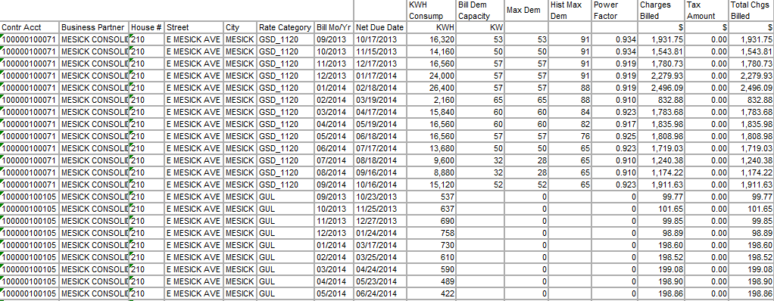

Report # 2:

Report name - Contract Account PF

Query level Restrictions/Filters:

- Operand should be restricted for
  - Power factor Installation fact - PWERFACTOR (Note: This will be decided during configuration and accordingly new operand should be used)
  - KW Max Demand – KW_MAX_DEM (Note: This will be decided during configuration and accordingly new operand should be used)
  - KW Max Demand for the year – KW_YR_MAXD
- Valid from greater than or equal to 01/01/2010

Selection Criteria/Screen -

Field Name | Selection Text / Description | Type of Field (Check Box / Radio Button / Select-Option / Parameter) | Search Help / Pick List / List of values  (Y / N) | Validation Required  (Y / N) | Default Value | Comment  ( Mandatory / Optional ) | Single/Multiple/Range/all possible combinations
Contract Account | Multiple Contract Accounts | BEx  Variable | Y | Y | None | Optional | Multiple
Installation Number | Installation: Optional | BEx Variable | Y | Y | None | Optional | All

Row Fields / Characteristics:

Name of the Field | Technical Name | Master Data Attribute | Restriction
Contract Account | 0CACONT_ACC |  | Selection Field
Installation Number | 0UCINSTALLA |  | Selection Field
Valid From | 0DATEFROM
Valid To | 0DATETO

Free Characteristics (for additional drill downs):

None required.

Columns / Key Figures:

Name of the Field | Technical Name | Type | Definition
Operand | 0UCOPERAND | Characteristics
Entry value | 0UCVAL_INT | Key Figure

BI Report layout:

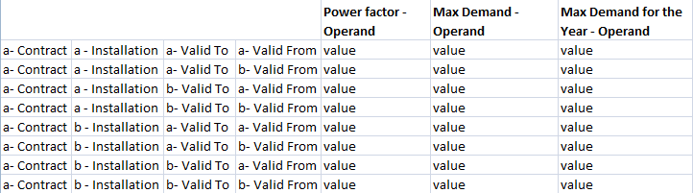

ADDITIONAL INFORMATION

Unit Test Plan

Information Security

Security Roles (Profiles and Authorizations)

No new security role or authorization objects to be created or changed for these reports due to the fact that the business users will use the same reports or new reports based on the existing reportable objects.

Redwood

There is no Redwood job to be created due to the fact that no new data flow will be developed for SAP BW. Existing process chain will bring in additional installation facts data to BW from ECC system.

Error Handling

Failure Points
Possible Point Of Failure | Rules For Handling Failure
Invalid selection parameter(s) | Standard Business Explorer Analyzer error
No Data found for Date Range | If the BW cube does not contain data for the selected parameters

Questions / Issues / Risks

None

Appendix

Data flow for of Infoset ZBLO_IS01:

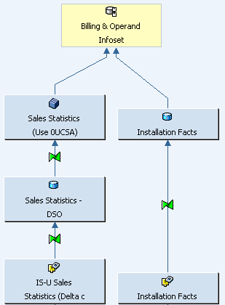

Data flow for of Billing Analysis Multiprovider ZEREV_M01:

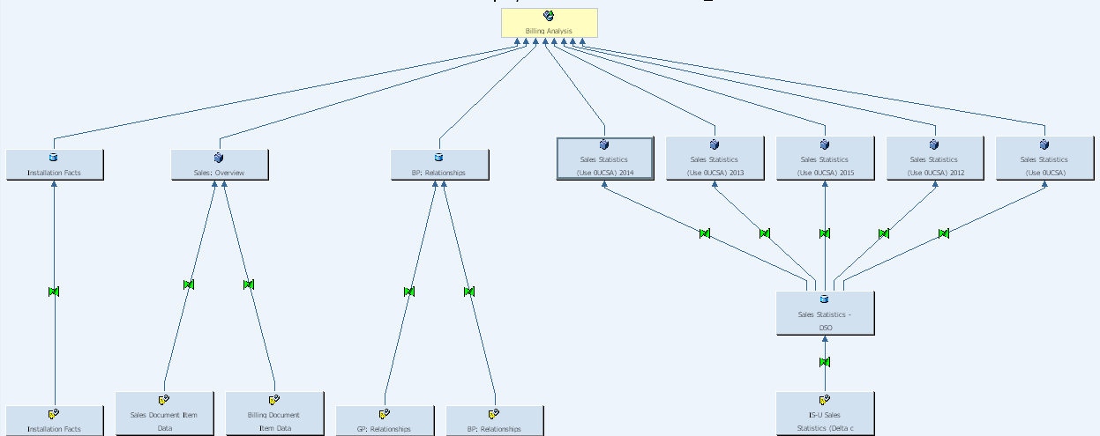

Data flow for of the Installation Facts DSO 0UCS_DS06:

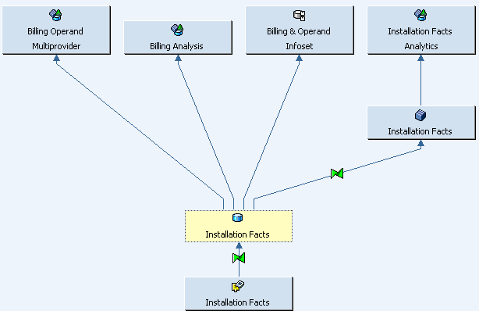

BEx Query Design: YBI_ZEREV_M01_MFA1106

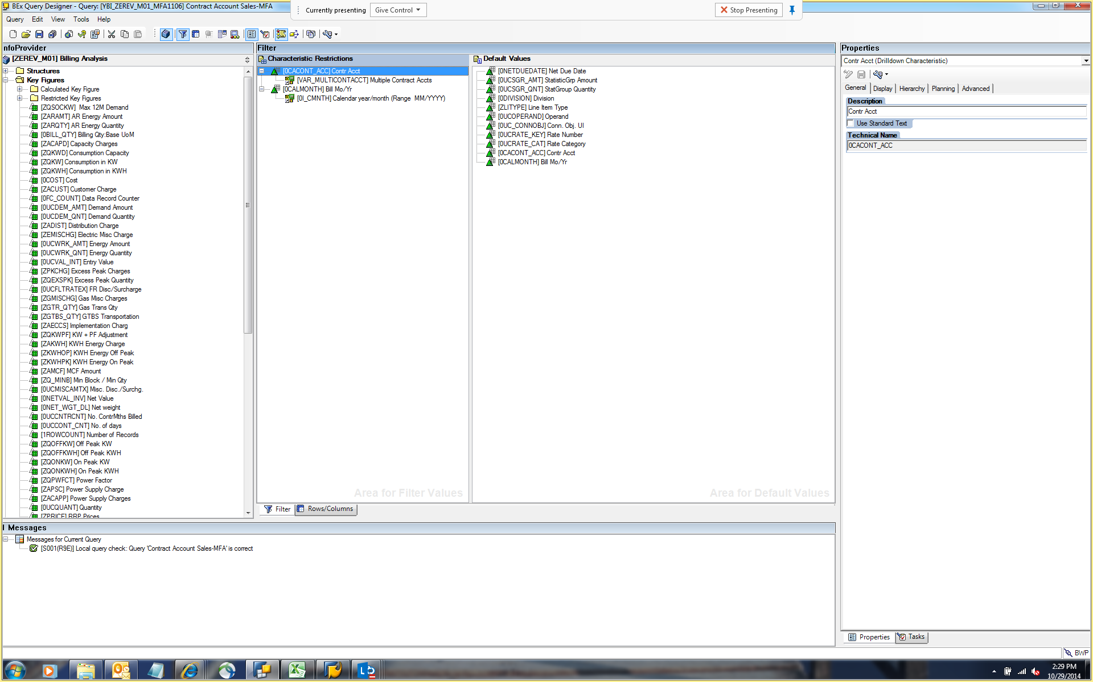

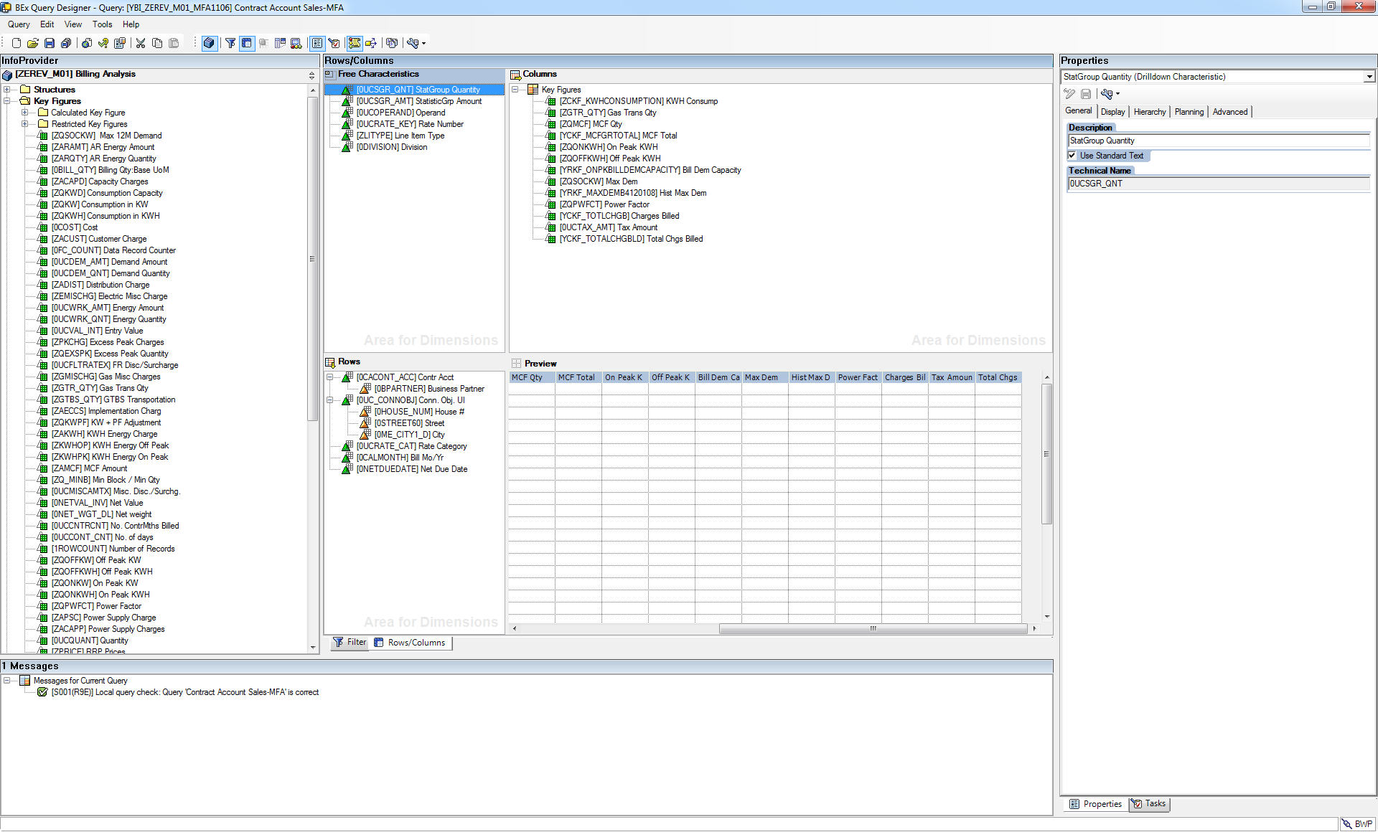

BEx Query Design: YBI_ZEREV_M01_MFA1106

